Isabelle Anno
9.22.2022
Chapter 4 Exercises- CAT database
1.) List the last name of each guide that does not live in Massachusetts (MA)
SELECT LAST_NAME FROM GUIDE WHERE (STATE <> 'MA');
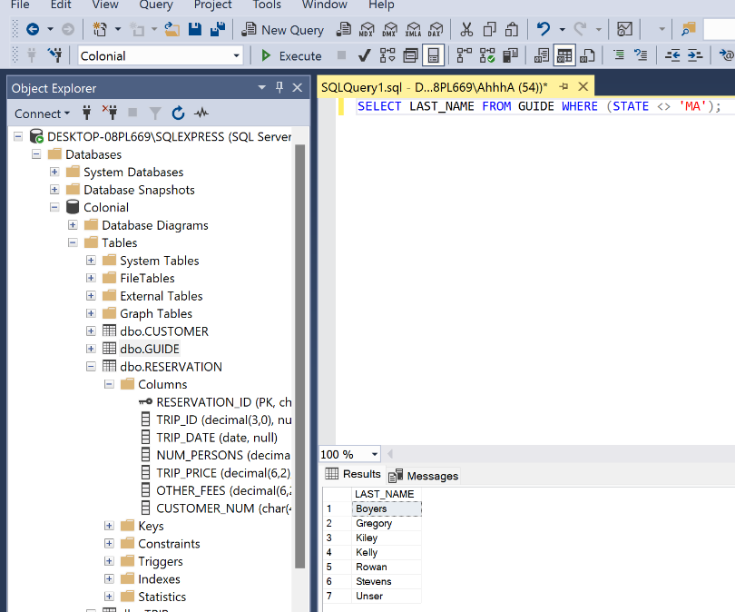
5.) List the customer number, customer last name, and customer first name of each customer that lives in New Jersey (NJ), New York (NY) or Pennsylvania (PA). Use the IN operator in your command.
SELECT CUSTOMER_NUM, LAST_NAME, FIRST_NAME FROM CUSTOMER WHERE STATE IN ('NJ','NY','PA');
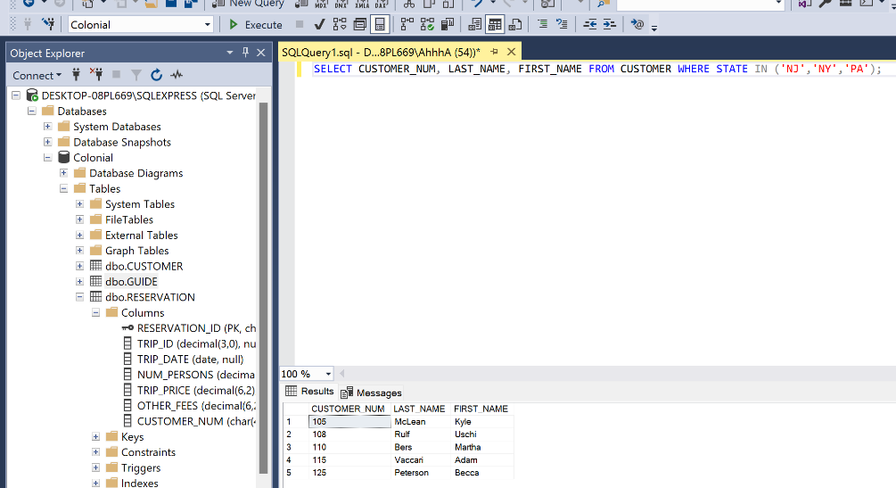

7.) How many trips are in the states of Maine (ME) or Massachusetts (MA)?

16
SELECT COUNT(TRIP_NAME) FROM TRIP WHERE(STATE ='MA' OR STATE = 'ME');

9.) How many reservations include a trip price that is greater than $20 but less than $75?
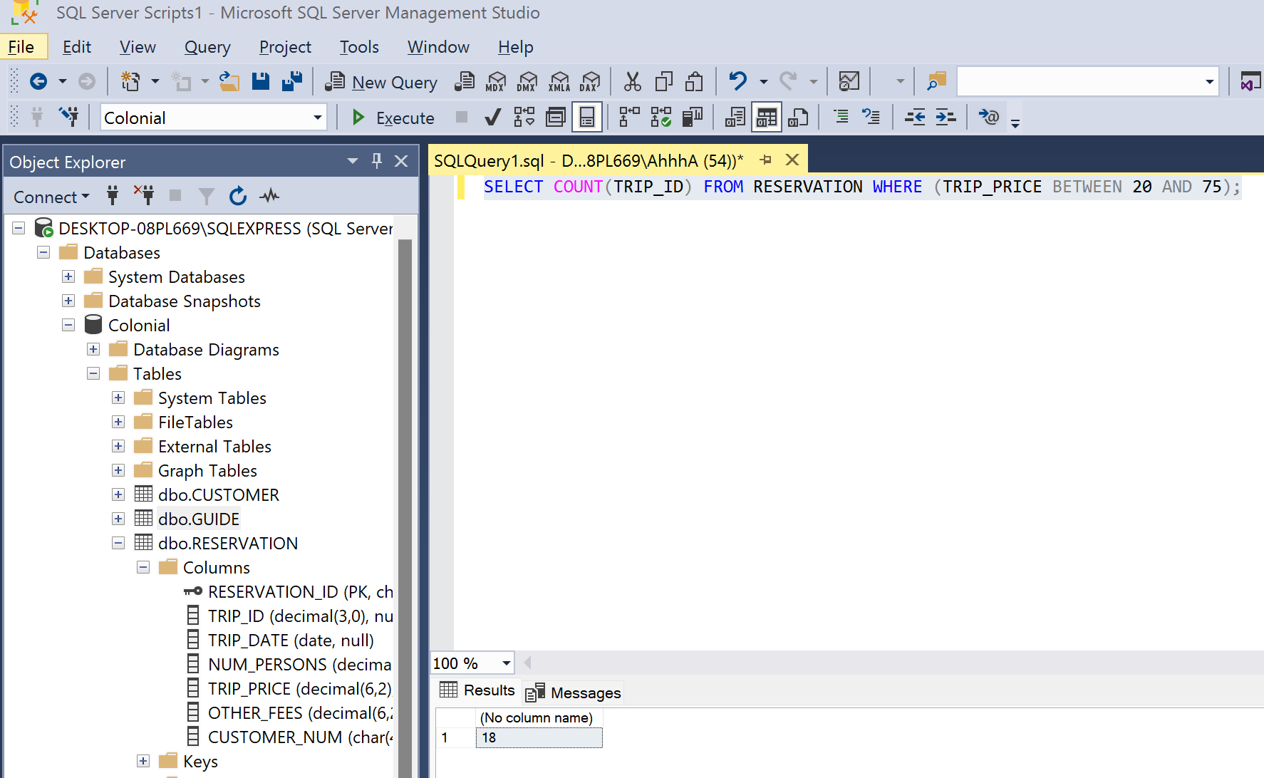
18
SELECT COUNT(TRIP_ID) FROM RESERVATION WHERE (TRIP_PRICE BETWEEN 20 AND 75);

13.) List the guide's last name and guide's first name for all guides that were hired before June 10, 2013.
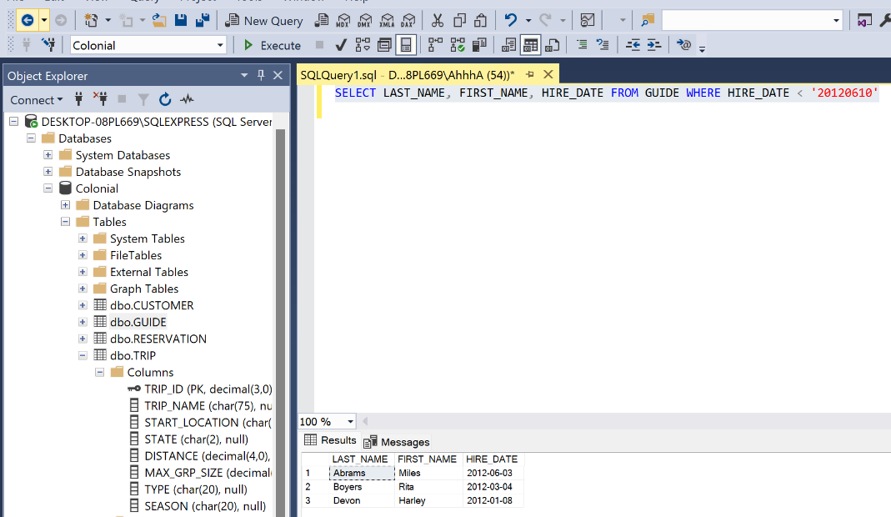
SELECT LAST_NAME, FIRST_NAME, HIRE_DATE FROM GUIDE WHERE HIRE_DATE < '20120610'

15.) Display the different seasons in which trips are offered. List each season only once.

SELECT DISTINCT SEASON FROM TRIP
17.) What is the longest distance for a biking trip?
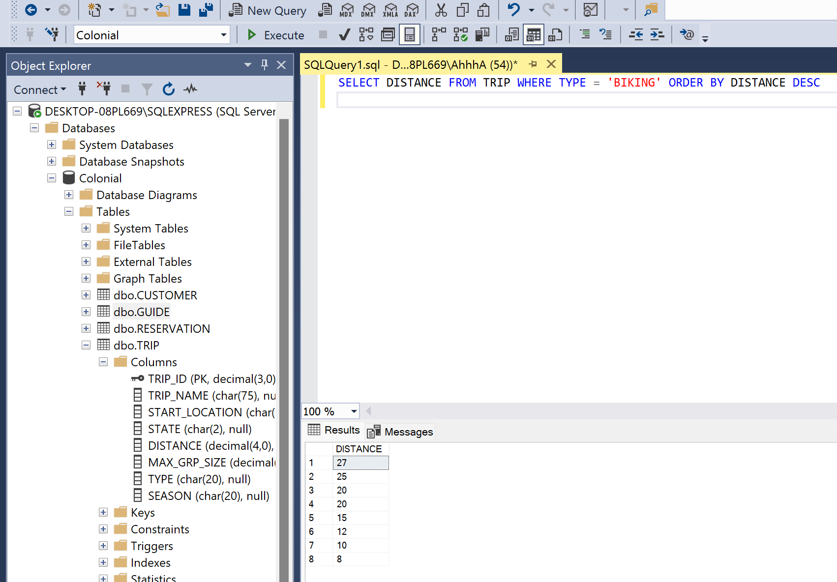
27
SELECT DISTANCE FROM TRIP WHERE TYPE = 'BIKING' ORDER BY DISTANCE DESC

